**Java Project Report**

* IntroductionThe project is on Supermarket Billing. Supermarket is the place where  
  customers come to purchase their daily using products and pay for that. So there is a need to calculate how many products are sold and to generate the bill for the customer.  
  In our project we have 2 users. First is the administrator who will enter the products in database and will decide the taxes and commissions on the products and can see the report of any product and employ the cashiers and enter their data to the database .  
  Second one is the bill calculating operator (cashiers) who will calculate the bill and print it .
* **Objective**

To develop java application for a supermarket with suitable GUI.

* Work FlowWork in the Supermarket will be done in the following way:  
  1. The product will come in the store.  
  2. Administrator will enter the information of the product in  
  database.  
  3. The Administrator will enter the taxes and commissions for each  
  product.  
  4. The customer will come and take the basket with him/her and choose  
  the product and took it to the counter.  
  5. The cashier will check the products with the bar code  
  detecting machine (future work ) or with item id then it will match with product-id then it will show its information and price and the bill will be calculated and total payment will shown.  
  6. Customer will pay for the products.  
  7. All the products will be packed and delivered to the customer.
* ModulesWe will use 5 modules in this project. These are as follows:  
  Module 1: Login–IdThis module is made for the login of users.  
  login-id is for:  
  1. Administrator  
  2. Cashier.  
  Module 2: Apply taxes and commissionsThis module is for administrator who will Set the price for the products.  
  Module 3: Check the ReportThis module is also for the administrator who can generate or check the report of the product and how many products are sold on particular date or in a period of time.  
  Module-4: Calculate the billThis module is for cashier who will  
  1. Calculate the bill.  
  2. Print it for the customer.
* **Requirements**
* **software requirements :**
* Login window

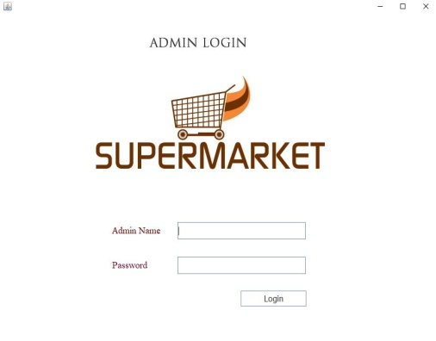 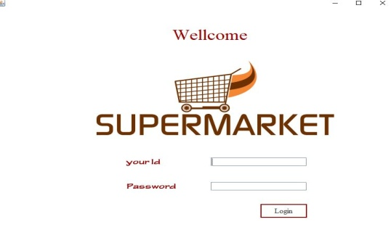

Then the GUI interface was created for the main login window which a simple way of protection and it specifies two sub-windows :

* The cashier window:

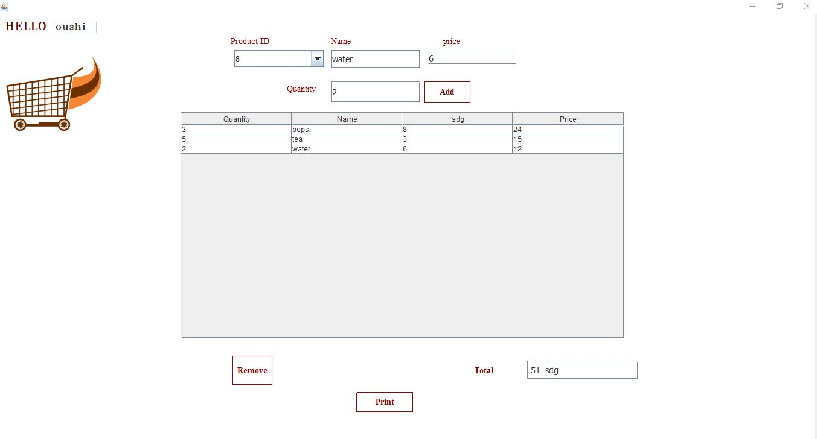

In this window you do not have a permission to edit , add or delete any of the products , it contains several fields such that you can enter the barcode of an item or you can scan it with the bar code scanner , the other fields contain the item attributes such as :

Name , id , tax and the date of insertion , then we have several buttons such that we can insert new item attribute into the database , then the system should calculate the sum the sub-sum.

* The administrator window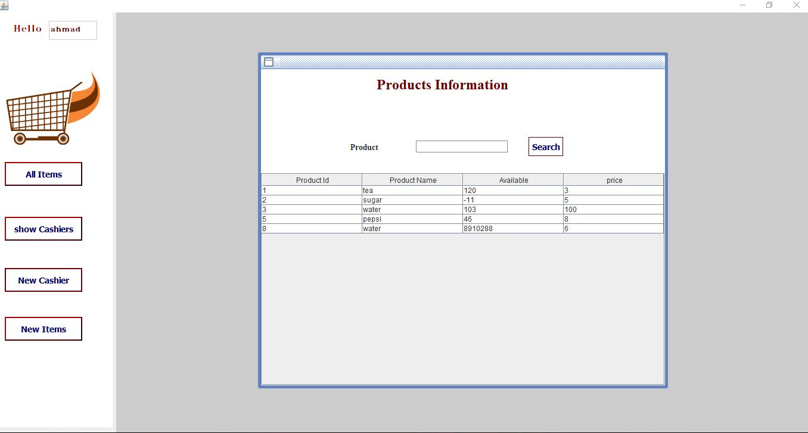

In this window the owner has the ability to add , insert or delete items , in the same way as the cashier window this window contains several fields such that you can insert new items , delete or update them by insert , delete , update buttons respectively .

* **Hardware requirements:**
* Barcode scanner device.
* Printer.
* Computer.
* **Future Works :**

Select Items by barcode scanner.

* **Done by**:
* Ahmed Abdelhady Mohammed 154008.
* Mohammed Bakheet Ali 154078.
* Mohammed Ali Mohammed Awad 154088.
* Database design:
* Database name : supermarket.
* Tables:
* Admin:

|  |  |  |  |  |  |
| --- | --- | --- | --- | --- | --- |
| username | varchar | Null |  |  |  |
| Password | varchar | Null |  |  |  |

* Casheirs:

|  |  |  |  |  |
| --- | --- | --- | --- | --- |
| Id | Int | Not null | Pk | Auto_increment |
| name | Varchar | Null |  |  |
| Num | Varchar | Null |  |  |
| Address | Varchar | Null |  |  |
| Email | Varchar | Null |  |  |
| Password | Varchar | Null |  |  |

* Items:

|  |  |  |  |
| --- | --- | --- | --- |
| Id | Int | Not null | Pk |
| pname | varchar | Null |  |
| available | int | Null |  |
| price | int | Not null |  |